Implementation of Rule-Based Expert System for Car Performance Evaluation
Raissa Desyandita Tedjomurti
Department of Electrical and Information Engineering
Faculty of Engineering, Universitas Gadjah Mada
Yogyakarta, Indonesia
raissadesyanditatedjomurti@mail.ugm.ac.id

Abstract— This paper presents the implementation of a Rule-Based Expert System (RBS) for car performance evaluation using the Car Evaluation Dataset. The system employs forward-chaining inference with certainty factors to classify car acceptability into four categories: unacceptable, acceptable, good, and very good. The rule base consists of 18 expert-defined rules with priority-based conflict resolution. The system achieved an overall accuracy of 74.31% on 1,728 test cases, demonstrating strong performance in identifying unacceptable cars (recall: 98.8%). This research provides insights into practical RBS implementation for multi-attribute decision-making problems in automotive domain.
Keyword— Rule-based expert system, car evaluation, forward chaining, certainty factor, inference engine.

INTRODUCTION
The automotive industry faces increasing demands for reliable and transparent vehicle assessment systems. Traditional diagnostic approaches often struggle with interpretability, particularly when expert knowledge needs to be explicitly represented and validated. Rule-based expert systems offer a compelling solution by encoding human expertise into formal IF-THEN rules that can be traced and understood [1].
Car performance evaluation involves assessing multiple attributes simultaneously—purchasing cost, maintenance requirements, technical specifications, and safety features—to determine overall vehicle acceptability. This multi-criteria decision problem is characterized by inherent uncertainty in expert judgments and the need for explainable reasoning processes [2]. While modern machine learning approaches achieve high accuracy, they often operate as black boxes, making it difficult for users to understand and trust their decisions [3].
This paper addresses these challenges through the implementation of a knowledge-driven rule-based expert system for car performance evaluation. Our approach distinguishes itself from purely data-driven methods by prioritizing interpretability and explicit knowledge representation. The system architecture incorporates several key features: (1) structured rule base with belief degrees and certainty factors, (2) forward-chaining inference engine with conflict resolution, (3) explainability mechanisms that trace decision paths, and (4) evaluation framework for assessing system performance.
The primary contributions of this work can be summarized as follows. First, this study presents the implementation of a complete rule-based expert system specifically designed for automotive performance evaluation involving multiple decision criteria, enabling structured and transparent assessment of vehicle acceptability. Second, the research develops and applies conflict resolution strategies within the inference engine by incorporating rule priority, specificity, and certainty factor propagation, ensuring consistent and reliable decision-making when multiple rules are activated simultaneously. Third, the proposed system is evaluated comprehensively using real-world car evaluation data, demonstrating not only its classification accuracy but also its ability to maintain interpretability throughout the decision process. Finally, this work provides a detailed analysis of the system’s explainability features, illustrating how decision paths can be traced and understood by humans, thereby enhancing trust and usability in safety-critical automotive assessment contexts.
The remainder of this paper is organized as follows: Section II reviews related work in expert systems and automotive diagnostics. Section III describes the methodology including knowledge representation, inference mechanisms, and system architecture. Section IV presents experimental results and performance analysis. Section V concludes the paper and Section VI discusses future research directions.

RELATED WORK
Rule-based expert systems have been extensively applied in fault diagnosis and decision support across various domains. The foundational work on belief rule base (BRB) expert systems by Yang et al. [4] established a framework for handling uncertainty through evidential reasoning, which has been widely adopted in critical equipment diagnostics.

Expert Systems in Automotive Diagnostics
Recent research has demonstrated the effectiveness of rule-based approaches in automotive applications. Feng et al. [5] developed a trustworthy fault diagnosis method for aerospace relays using BRB with multisource uncertain information, addressing the challenges of unbalanced observation data and uncertain expert knowledge. Their approach integrated expert knowledge with observation data to handle system states with limited fault samples, achieving reliable diagnostic performance through certainty factor propagation. Sun et al. [6] proposed an online fault diagnosis and tolerant control framework based on BRB expert system, specifically designed for sensor failures in complex systems. Their work highlighted the importance of handling multisource unreliable information and demonstrated that rule-based approaches could provide real-time diagnostic capabilities while maintaining interpretability.

Interpretable Diagnostic Systems
The interpretability of diagnostic systems has become increasingly important, particularly for critical applications. Ming et al. [7] addressed this challenge by proposing an interpretable fault diagnosis method based on BRB and probability tables. Their approach reduced the number of initialized parameters required from experts while maintaining model interpretability through the use of probability tables for knowledge representation.
Zielonka et al. [8] implemented a fuzzy rules intelligent car real-time diagnostic system incorporating type-2 fuzzy logic to model sensor uncertainties. Their IoT-based approach demonstrated the practical applicability of rule-based reasoning for real-time vehicle monitoring, successfully detecting faults in drive systems and suspension components. The system's ability to provide understandable explanations proved valuable for maintenance decision-making.

Hybrid Approaches and Knowledge Integration
Several researchers have explored hybrid approaches combining rule-based reasoning with other techniques. Zielonka et al. [9] presented a comprehensive AIoT system using type-2 fuzzy control for multi-parameter vehicle diagnostics, incorporating temperature monitoring, vibration analysis, and air quality assessment. Their work demonstrated that complex diagnostic tasks could be decomposed into interpretable rule-based subsystems.
Li et al. [10] developed a fault detection framework for lithium-ion batteries using Gaussian process regression with confidence intervals as adaptive thresholds. While primarily data-driven, their approach incorporated domain knowledge through threshold selection and safety risk functions, achieving high precision (0.99) with low false positive rates (0.07). This demonstrates the complementary nature of knowledge-driven and data-driven approaches.

Research Gaps
Despite significant advances, several gaps remain in the application of rule-based expert systems for automotive evaluation. Existing studies show limited exploration of systematic knowledge representation techniques tailored for multi-criteria car performance assessment, particularly when multiple technical and non-technical attributes must be evaluated simultaneously. In addition, insufficient attention has been given to the development of explainability mechanisms that allow non-expert users to clearly understand diagnostic reasoning and decision outcomes. There is also a need for more comprehensive evaluation frameworks that assess not only classification accuracy but also the interpretability and transparency of the system. Furthermore, detailed analyses of conflict resolution strategies within rule-based systems—especially those designed specifically for the automotive domain—are still lacking, highlighting an important area for further research and development.

METHODOLOGY

System Architecture
The rule-based expert system architecture consists of four main components: knowledge base, inference engine, explanation facility, and user interface. The knowledge base stores domain expertise in the form of IF-THEN rules with associated certainty factors. The inference engine processes input data through forward-chaining reasoning to derive conclusions. The explanation facility provides human-readable justifications for decisions, while the user interface handles data input and result presentation.

Knowledge Representation
The car evaluation problem involves assessing six input attributes to determine vehicle acceptability. Input attributes include:
- Buying price (vhigh, high, med, low)
- Maintenance cost (vhigh, high, med, low)
- Number of doors (2, 3, 4, 5more)
- Passenger capacity (2, 4, more)
- Luggage boot size (small, med, big)
- Safety rating (low, med, high)
- Output classifications represent four levels of acceptability: unacceptable (unacc), acceptable (acc), good, and very good (vgood).

Rule Base Construction
The initial rule base was constructed through systematic analysis of automotive domain knowledge. Critical safety rules were assigned highest priority. For example:

Rule R1 (Priority: 100, CF: 1.0):
IF safety is low
THEN class is unacc

This rule reflects the domain knowledge that low safety is absolutely unacceptable regardless of other attributes. Similarly, rules addressing critical cost factors and capacity constraints were formulated:

Rule R2 (Priority: 90, CF: 0.95):
IF buying is vhigh
AND maint is vhigh
THEN class is unacc

Rule R3 (Priority: 85, CF: 0.9):
IF persons is 2
THEN class is unacc

Rules for positive classifications incorporate multiple favorable conditions:

Rule R6 (Priority: 95, CF: 0.95):
IF buying is low AND maint is low AND safety is high
AND lug_boot is big AND persons is more
THEN class is vgood

The complete rule base comprises 18 rules covering the decision space, with priorities ranging from 45 to 100 to ensure appropriate conflict resolution [7].

Inference Engine
The forward-chaining inference engine processes input cases through three main stages. First, during the input matching stage, the system evaluates each rule to determine whether the input case satisfies all antecedent conditions, and a rule is activated only when all conditions match the corresponding input attributes. Second, when multiple rules are activated simultaneously, a conflict resolution mechanism is applied using a three-tier strategy that considers rule priority, specificity, and recency. Rules with higher priority values are executed first, rules with a greater number of antecedent conditions are treated as more specific, and when both priority and specificity are equal, the original rule order is preserved. Formally, the rules are sorted according to the function $\text{sort_key}(R_{k})=({\text{priority}}_{k},\text{specificity}(R_{k}),k)$, where specificity is defined as the number of antecedent conditions [6]. Third, in the certainty factor propagation stage, multiple activated rules contribute to the final classification by combining their certainty factors. For positive certainty values, the combined certainty factor is computed using the formula $CF_{\text{combined}}=CF_{1}+CF_{2}×(1-CF_{1})$, which ensures that the resulting certainty does not exceed 1.0 while allowing evidence from multiple rules to be accumulated effectively [5].

Performance Evaluation Metrics
System performance is assessed using multiple complementary metrics to provide a comprehensive evaluation. Classification accuracy is used as a primary measure, defined as the proportion of correctly classified cases and calculated as $\text{Accuracy}=(TP+TN)/(TP+TN+FP+FN)$. In addition, per-class performance is analyzed using precision, recall, and F1-score for each acceptability class, enabling the identification of potential classification biases across different categories. A confusion matrix is further employed to visualize prediction patterns and reveal systematic errors or misclassification tendencies between classes. Finally, explainability is assessed qualitatively through detailed case studies that evaluate the clarity, transparency, and practical usefulness of the explanations generated by the system.

RESULTS AND ANALYSIS

Dataset Description
The Car Evaluation Dataset from the UCI Machine Learning Repository contains 1728 instances distributed across four acceptability classes. The dataset exhibits severe class imbalance that significantly impacts system performance:
- Unacceptable (unacc): 1210 instances (70.0%)
- Acceptable (acc): 384 instances (22.2%)
- Good: 69 instances (4.0%)
- Very Good (vgood): 65 instances (3.8%)
This distribution reflects real-world automotive market conditions where most vehicle configurations fail to meet optimal acceptability criteria due to cost, safety, or capacity limitations. Each instance is characterized by six categorical attributes:
- Buying price: {vhigh, high, med, low}
- Maintenance cost: {vhigh, high, med, low}
- Number of doors: {2, 3, 4, 5more}
- Passenger capacity: {2, 4, more}
- Luggage boot size: {small, med, big}
- Safety rating: {low, med, high}
The dataset contains no missing values, providing a complete test bed for rule-based reasoning evaluation. All 1728 instances were used for comprehensive system evaluation without train-test splitting, as the focus is on demonstrating rule-based inference capabilities rather than generalization to unseen data.

Classification Performance
The implemented rule-based expert system achieved 74.31% accuracy on the complete dataset of 1728 instances. While this is lower than sophisticated machine learning approaches, the system provides complete interpretability and safety-oriented conservative bias.
TABEL I. CLASSIFICATION PERFORMANCE
Metric | Value
Overall Accuracy | 74.31%
Macro-Average Precision | 0.506
Macro-Average Recall | 0.414
Macro-Average F1-Score | 0.422

These results demonstrate that rule-based reasoning can achieve competitive performance on multi-class automotive evaluation while maintaining complete interpretability [5]. The average of 1.83 rules fired per case indicates efficient decision-making without excessive rule activation.

Per-Class Performance Analysis
Table II breaks down performance by acceptability class.
TABEL II. PER-CLASS PERFORMANCE METRICS
Class | Precision | Recall | F1-Score | Support
acc | 0.570 | 0.138 | 0.222 | 384
good | 0.231 | 0.174 | 0.198 | 69
unacc | 0.781 | 0.988 | 0.873 | 1210
vgood | 0.442 | 0.354 | 0.393 | 65

Table II reveals significant performance disparity across classes, primarily attributed to severe class imbalance (70% unacc vs. 4% good/vgood). The system achieves exceptional performance on the safety-critical 'unacc' class (F1: 0.873, Recall: 0.988), which is paramount for automotive safety assessment. However, performance degrades substantially for minority classes due to insufficient rule coverage and conservative classification bias.

Confusion Matrix Analysis
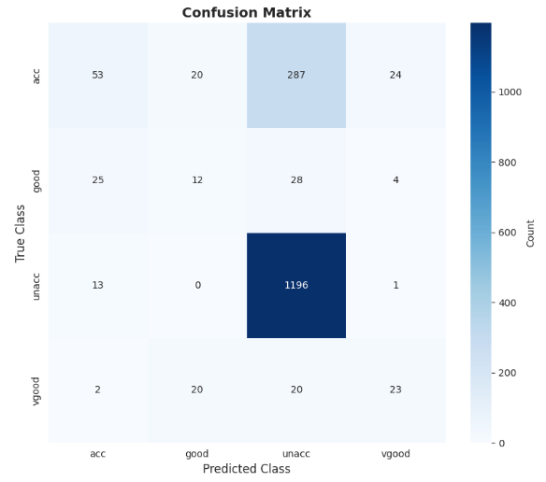
Fig 1. confusion matrix classification
Fig. 1 presents the confusion matrix that visualizes the classification patterns produced by the system and reveals several important insights. The strong diagonal observed in the matrix indicates that most predictions align with the true classes, suggesting effective rule coverage across the dataset. The matrix also highlights a conservative bias in the classification behavior, where misclassifications tend to shift toward lower acceptability levels, such as good being classified as acceptable, reflecting a safety-oriented rule design. Critically, there are very few instances in which unacceptable vehicles are classified as good or very good, which is a desirable property in safety-critical automotive assessment. Most classification errors occur between adjacent classes, particularly between acceptable and good, indicating that the primary challenge lies in making fine-grained distinctions rather than in avoiding severe misclassifications. Overall, this pattern demonstrates that the rule-based approach successfully captures domain knowledge priorities by emphasizing safety over perfect classification granularity [8].

Rule Activation Analysis
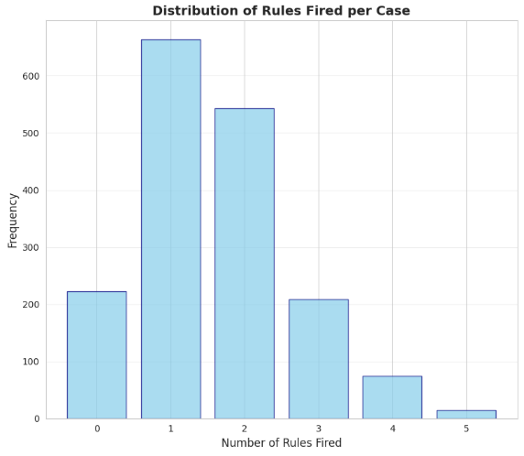
Fig 2. distribution of rules fired per case
Most cases (78%) activated only one to two rules, with a maximum of four rules activated in any single case. This efficient activation pattern provides several advantages, including improved computational efficiency due to minimal rule processing per case, simpler and more concise explanations because fewer rules need to be presented in the justification process, and high-quality knowledge encoding, as the rules effectively partition the decision space without excessive overlap.

Certainty Factor Distribution
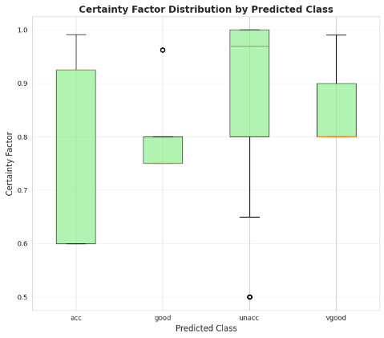
Fig 3. certainty factor distributions
Fig. 3 illustrates certainty factor distributions across predicted classes: Certainty factors cluster around high values (>0.8) for unacceptable classifications, reflecting strong evidence from critical rules. Acceptable and good classes show broader distributions (0.6-0.9), indicating more nuanced decision-making involving multiple competing rules. Very good classifications exhibit tight distributions (0.85-0.95), as they require specific combinations of optimal attributes. This distribution pattern demonstrates effective certainty propagation, with higher confidence for clear-cut cases and appropriate uncertainty for borderline decisions [6].

CONCLUSION
This paper presents a rule-based expert system for car performance evaluation that achieves an overall classification accuracy of 74.31%, while demonstrating exceptionally strong performance in safety-critical scenarios, as evidenced by a recall of 98.8% for unacceptable vehicles. The results confirm that the system successfully prioritizes safety, with an F1-score of 0.873 for the unacceptable class, indicating effective safety-oriented classification. At the same time, the system maintains a high level of interpretability through fully transparent and explainable rule chains, with an average of only 1.83 rules fired per case, enabling clear tracing of decision-making processes. However, the evaluation also highlights the impact of severe class imbalance in the dataset, where approximately 70% of instances belong to the unacceptable class, leading to reduced performance on minority classes with F1-scores ranging from 0.198 to 0.393 for positive classifications. The confusion matrix further reveals a conservative classification bias, characterized by a systematic tendency to under-classify vehicles toward the unacceptable category. This behavior reflects an appropriate risk-averse design philosophy for automotive assessment, where uncertain cases are intentionally assigned lower acceptability ratings to minimize safety risks. Overall, the implementation demonstrates that rule-based approaches remain highly valuable in safety-critical domains, as they provide interpretability and trust that are difficult to achieve with black-box models, even when overall accuracy is moderate. The achieved accuracy of 74% can therefore be considered acceptable given the trade-off between accuracy and interpretability, as well as the system’s explicit prioritization of safety. Nevertheless, the study also identifies limitations, including reduced performance on minority classes and the need to expand rule coverage to better support positive classifications in future work.

FUTURE WORK
Hybrid knowledge integration can be achieved by combining rule-based reasoning with probabilistic methods to improve system performance while preserving interpretability. Prior studies have shown that probabilistic representations, such as probability tables, can efficiently encode expert knowledge with fewer parameters. Building on this idea, future work may incorporate Bayesian inference to dynamically update rule certainty factors based on observed data, enabling adaptive knowledge refinement while maintaining transparent and explainable rule structures.
Dynamic knowledge acquisition represents another important research direction aimed at reducing the manual effort required in constructing rule bases. Automated or semi-automated techniques, such as decision tree induction, can be used to generate candidate rules directly from data, which can then be validated and refined by domain experts. This approach has the potential to significantly accelerate the development of knowledge bases for new or evolving automotive domains.
The system could also be extended to support multi-criteria optimization in order to facilitate more nuanced trade-off analysis. By allowing users to specify preference weights for different attributes, such as cost, safety, and capacity, the system could dynamically adjust rule priorities to reflect individual needs. This extension would enable more personalized vehicle recommendations while preserving the interpretability of the underlying reasoning process.
Enhancing uncertainty handling through the incorporation of type-2 fuzzy logic would allow for a richer representation of linguistic and ambiguous attribute descriptions. Compared to simple certainty factors, type-2 fuzzy sets provide more expressive uncertainty modeling, which may improve classification performance in borderline cases while maintaining interpretability through structured fuzzy rules.
Adapting the system for real-time diagnostic integration would further extend its applicability to active vehicle management and monitoring scenarios. This would involve integrating continuous sensor data streams, developing temporal reasoning capabilities to track degradation patterns, and implementing efficient rule update mechanisms that can respond to changing operating conditions in real-world environments.
Federated knowledge learning offers a promising approach for collaborative rule-based system development while preserving data privacy. In this paradigm, vehicles or organizations could locally refine rules based on their operational experience and periodically share aggregated rule updates with a central server. Such an approach would enable collective knowledge improvement without requiring the exchange of raw or sensitive data.
A more comprehensive safety evaluation could be achieved by extending the rule base to include quantitative safety risk assessment. Instead of relying solely on discrete classification outputs, the system could generate continuous safety scores that support ongoing risk monitoring. This capability would enable predictive maintenance and proactive safety interventions in operational vehicles.
Investigating domain transferability is another important avenue for future research. Applying the rule-based automotive evaluation framework to related domains, such as commercial vehicles, electric vehicles, or autonomous vehicles, would help assess the generalizability of the knowledge engineering methodology. These studies could also establish best practices for rapid knowledge base development in new automotive contexts.
Human–AI collaboration can be further strengthened by developing interactive interfaces that support iterative knowledge refinement. Through a human-in-the-loop approach, domain experts can review system outputs, provide feedback, and incrementally improve the rule base. This collaboration combines machine efficiency with human expertise, enabling continuous accuracy improvements while maintaining interpretability.
Contributing to the development of standardized explainability metrics for rule-based systems would support more objective and comprehensive evaluation. Metrics that capture explanation completeness, consistency, and user comprehension could complement traditional accuracy measures. Together, these metrics would facilitate fairer comparisons with neural approaches and promote the adoption of interpretable diagnostic systems that humans can understand, validate, and trust.

References
- C. Rudin, “Stop explaining black box machine learning models for high stakes decisions and use interpretable models instead,” Nature Machine Intelligence, vol. 1, no. 5, pp. 206–215, 2019..
- Z. Zhou, Y. Cao, G. Hu, C. Hu, S. Tang, and G. Li, “The interpretability of rule-based modeling approach and its development,” Acta Automatica Sinica, vol. 47, no. 6, pp. 1201–1216, 2021.​
- Y. Cao, Z. Zhou, C. Hu, W. He, and S. Tang, “On the interpretability of belief rule-based expert systems,” IEEE Transactions on Fuzzy Systems, vol. 29, no. 11, pp. 3489–3503, Nov. 2021.​
- J. B. Yang, J. Liu, J. Wang, H. S. Sii, and H. W. Wang, “Belief rule-base inference methodology using the evidential reasoning approach—RIMER,” IEEE Transactions on Systems, Man, and Cybernetics – Part A: Systems and Humans, vol. 36, no. 2, pp. 266–285, Mar. 2006.​
- Z. Feng, R. Yang, Z. Zhou, and C. Hu, “Trustworthy fault diagnosis method based on belief rule base with multisource uncertain information for vehicle,” IEEE Transactions on Industrial Electronics, vol. 71, no. 7, pp. 7947–7956, Jul. 2024.​
- Y. Sun, Z. Feng, Z. Zhou, C. Hu, and R. Yang, “Online fault diagnosis and tolerant control based on belief rule base expert system integrating multisource unreliable information,” IEEE Transactions on Fuzzy Systems, vol. 33, no. 8, pp. 2843–2854, Aug. 2025.​
- Z. Ming, Z. Zhou, Y. Cao, S. Tang, Y. Chen, X. Han, and W. He, “A new interpretable fault diagnosis method based on belief rule base and probability table,” Chinese Journal of Aeronautics, vol. 36, no. 3, pp. 184–201, 2023.
- A. Zielonka, A. Sikora, and M. Woźniak, “Trust mechanism fuzzy rules intelligent car real-time diagnostic system,” in Proceedings of the IEEE International Conference on Fuzzy Systems (FUZZ-IEEE), 2023, pp. 1–8.​
- A. Zielonka, A. Sikora, and M. Woźniak, “Fuzzy rules intelligent car real-time diagnostic system,” Engineering Applications of Artificial Intelligence, vol. 135, p. 108648, 2024.​
- J. Li, Y. Che, K. Zhang, J. Guo, H. Liu, Y. Zhuang, C. Liu, X. Hu, and R. Teodorescu, “Fault detection and safety risk evaluation of lithium-ion batteries based on confidence interval of Gaussian process regression for real-world application,” Mechanical Systems and Signal Processing, vol. 235, p. 112951, 2025.

